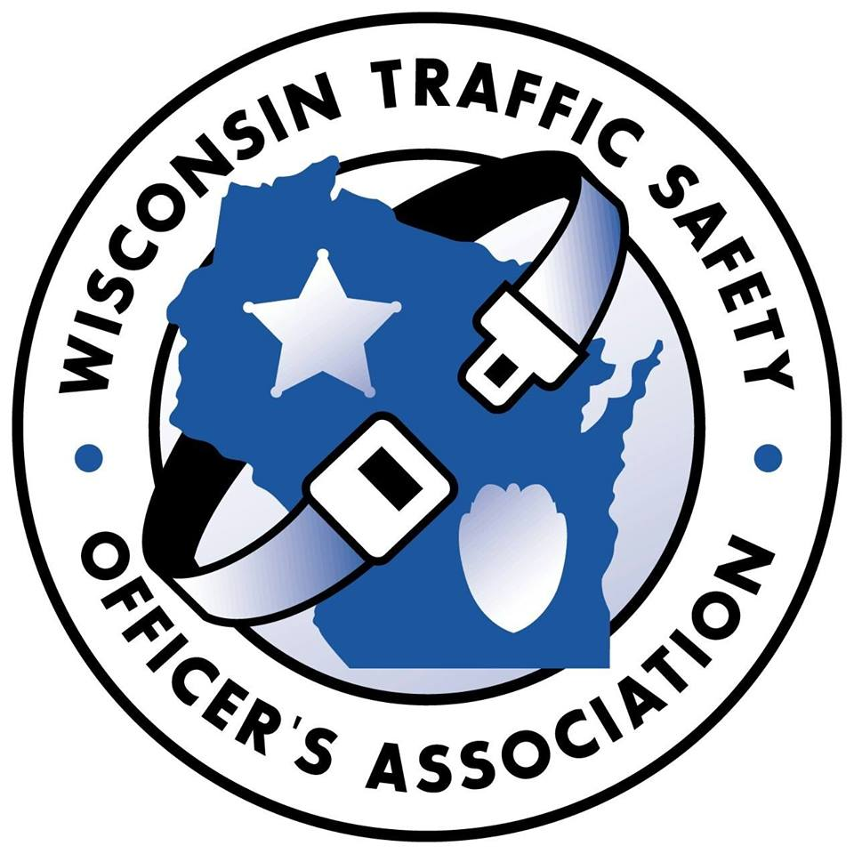
WISCONSIN TRAFFIC SAFETY OFFICER’S ASSOCIATION

Annual Training Conference for Traffic Safety Professionals
Monday-Tuesday-Wednesday, February 22th-24th, 2021
Stevens Point, WI.

Lodging reservations call 715-344-0200 or 1-855-267-7584.

Mention WTSOA Annual Conference
Room block at state rate ($82.00 single) available through January 10, 2020.
www.StevensPointWIHotel.com

**Due to COVID-19, on February 1, 2021 it will be determine if the conference will continue as planned or be cancelled. You will receive a full refund of your registration fee upon cancellation. **

CONFERENCE REGISTRATION FORM

Name:

Rank or Title: Agency:

Address:

City & Zip:

Phone:

Email:

Tuesday Luncheon Choice: Chicken Beef

*Registration Fee is $200.00 which includes most meals.

**Registration forms can be emailed or mailed to the below address.

****If you pay via PAYPAL, the registration fee is $205.00 ($5.00 service fee).

Please select payment method

Bill agency If you choose this method, please add the name and email address of the

person responsible for payment. Invoices will be emailed to this person.

Name: Email:

Check Enclosed Payable to WI Traffic Safety Officer’s Association

Mail or email completed form to:

Registration Coordinator
507 Hogan Trail
Sobieski, WI 54171
WITrafficSafety@gmail.com

