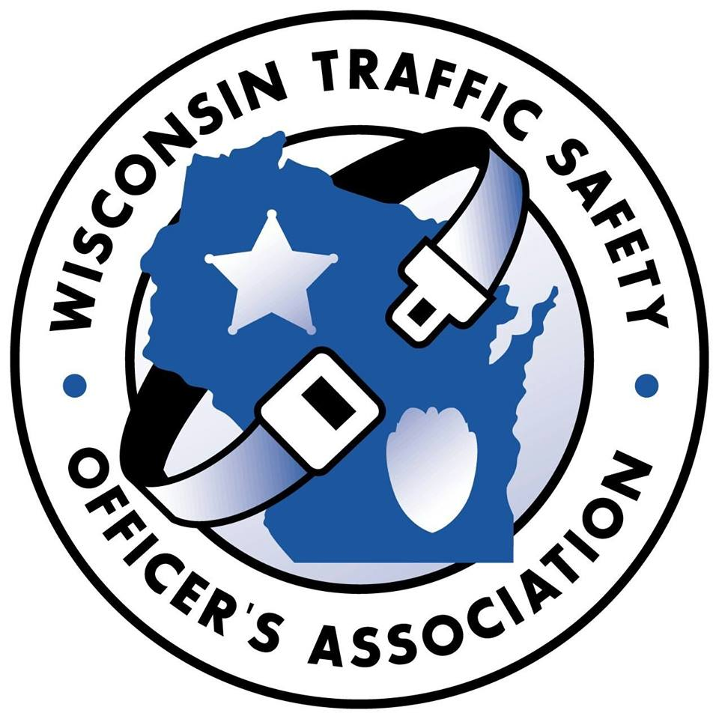
WISCONSIN TRAFFIC SAFETY OFFICER’S ASSOCIATION

Annual Training Conference for Traffic Safety Professionals
Monday-Tuesday-Wednesday, February 28, March 1st and 2nd, 2022
Pewaukee, WI

Lodging reservations

https://www.theinglesidehotel.com/ or (262)547-0201

Mention WTSOA Annual Conference
Room block at state rate ($82.00 single) available through February 1, 2022.

CONFERENCE REGISTRATION FORM

Name:

Rank or Title: Agency:

DRE: Yes No

Address:

City & Zip:

Phone:

Email:

Tuesday Luncheon Choice: Chicken Beef

*Registration Fee is $225.00 which includes most meals.

**Registration forms can be emailed or mailed to the below address.

****If you pay via PAYPAL, the registration fee is $235.00 ($10.00 service fee).

Please select payment method

Bill agency If you choose this method, please add the name and email address of the

person responsible for payment. Invoices will be emailed to this person.

Name: Email:

Check Enclosed Payable to WI Traffic Safety Officer’s Association

Mail or email completed form to:

Registration Coordinator
1157 9th Avenue
Grafton, WI 53024
WITrafficSafety@gmail.com

